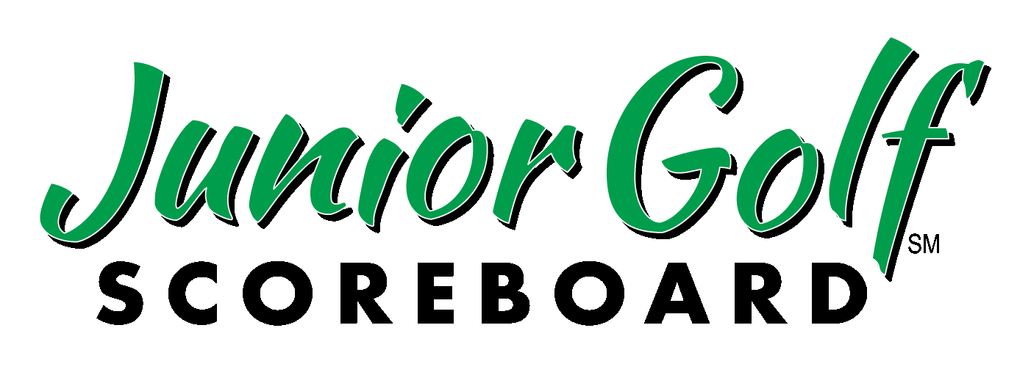

Following Competitive Junior Golf
Since 1998

4510 Cox Rd
Suite 303
Glen Allen, VA 23060

Phone 804-935-1800
Fax 804.527.0834

Web Site
juniorgolfscoreboard.com

4470 Cox Rd
4470 Cox R

January 20, 2025

To: All State Golf and Junior Golf Associations, PGA Sections, Junior Golf Tours, Independent Junior Golf Tournaments.

Fr: Mac Thayer – Executive Director

Subj: 2025 Guidelines for Reporting and publishing of player DQ’s, WD’s, NS’s and NC’s Please forward to relevant staff

In order to achieve consistency throughout the sport, we have encouraged you all in the past, to voluntarily consider adopting the policies outlined below. This could relieve tournament officials from trying to determine the reason or cross-examining players as to why they are not finishing an event. It places the burden on the player to explain the reason to whomever might ask them later about their reason for not continuing play.

We do recognize that no-cards (NC’s) are sometimes the most problematic but, it is the number one complaint that we get from parents whose children they have taught to finish. When they see competitors quitting in the middle of a round, it gives the perception those families are “gaming the system”.

Please take time to review the chart attached and forward to your junior tournament directors.. Please also note that your decisions about a player’s status are yours alone and are final. We will forward all questions about a particular player or situation to your organization.

In addition, both college golf coach associations (GCAA and WGCA) have issued a joint letter written to the junior golf community about coaches’ attitude towards junior golf withdrawals. That letter is attached for you to use as you see fit. You are permitted and encouraged to publish that letter and this one or copy any portion for your “tour policies” on your website and/or to distribute copies to your players or members in membership materials or at tournaments.

Please see the chart below that outlines the use and guidelines of DQ, WD, NS and NC. These were designed as a result of the conversations we mentioned.

Please feel free to call with any questions. Your input is welcome. All final decisions rest with your tournament officials or tour/event staff or committee.

(more)

Category name | Designation | Explanation | Report to Junior Golf Scoreboard
No show before competition begins | DNS  please get your provider to add DNS to your codes | Those players who do not come to the tournament at all | NO  Each organization handles internally
Disqualified | DQ | Reserved for actual USGA rules infraction that occurs without a deliberate or managed intention. NOTE:FAILURE TO APPEAR AL ALL FOR A TEE TIME AT ALL IS NOT A DQ. SEE “no show” below. | YES + any official scores
Withdrawal | WD | Reserved for a deliberate voluntary action or decision not to continue play after having started a competition notified an official, and turned in an official score for the stipulated round(s). OR  Reserved for a player stopping play mid-round who has a compelling visible, verifiable or an extremely very special reason – vomiting, cuts, swollen ankle, bee stings, death in the family, for example – otherwise see NC below. (Hurt wrist bad back, don’t feel well would not be considered visible or verifiable) lOf course – your decision) | YES + any official scores
No show | NS | Completed one or more rounds – fails to report for tee time and previously has not notified anyone | YES + any official scores
See next page
No card  (worst action by player) | NC | After having begun competition – a deliberate decision not to sign or turn in a card, walks off the course, etc  Clarification 2022 -  Proof of medical treatment can change NC to WD if tournament decides. Then call us. Always your decision. | YES + any official scores  We ask that if a player tees off, you include that player with the appropriate mark. Do not send in incomplete round scores, but instead send us the mark given. Ex: A player finishes Round 1 with a 75 but quits mid-round in Round 2 on Hole 9 with a score of 50, and quits without signing a scorecard: Send that in as a 75-NC.

Examples:

1) Player does not come to tournament at all – handled by tournament organization – do not report

2) Player tees it up, plays a complete or partial stipulated round, walks off without turning in scorecard for any reason - NC (Deliberate decision by player)(report all scores for rounds completed)

3) Player tees it up, plays, signs card, does not call or speak to an official, fails to show for next round – NS (Deliberate decision by player by not coming to course, calling or speaking to an official)(report all scores)

4) Player plays, signs card, actually comes to course reports late for tee time or calls to acknowledge being late, – DQ (While this might be deliberate,giving benefit of the doubt)

4a) Calls to say they are sick – WD

5) Player tees it up, plays, signs card, notifies official that they will not be playing next round, for any reason – WD (Deliberate decision by player to withdraw)(report all scores)

6) Player unintentionally fails to sign scorecard – DQ (Unintentional action by player)

7) Player fails to sign card after being given an opportunity to do so – NC (Deliberate decision by player)(report all scores)

